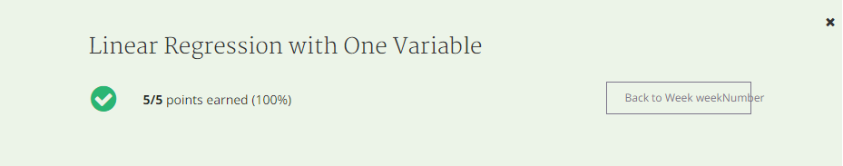

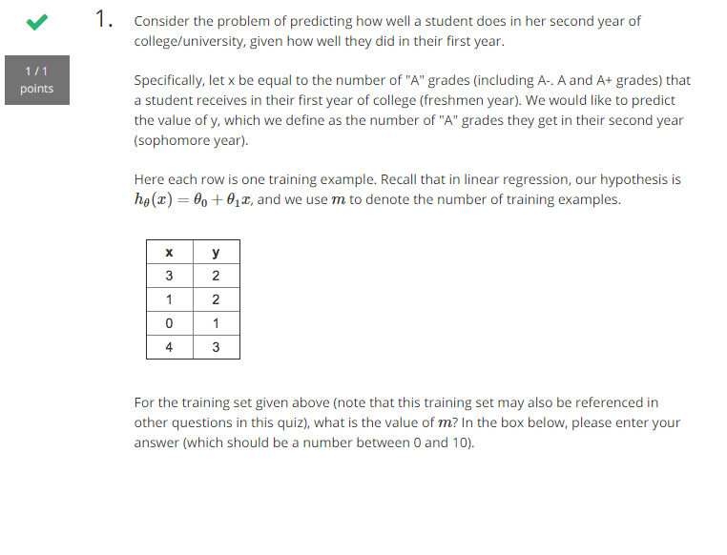

Answer: m=5

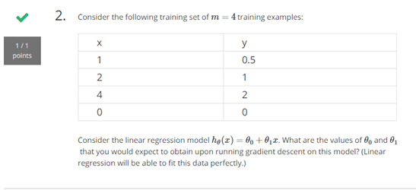

Answer:

θ0 = 0

θ1 = 0.5

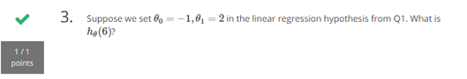

Answer: 11

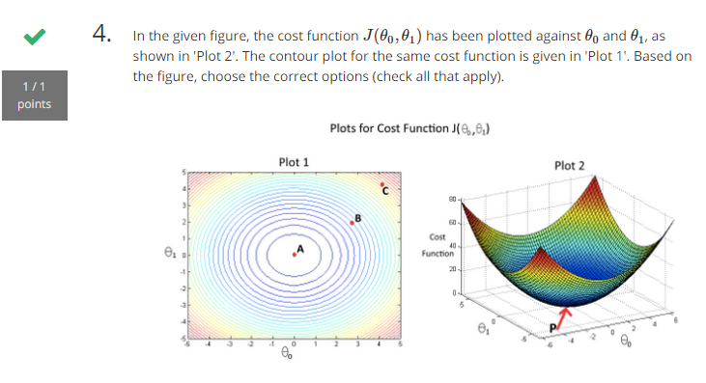

Answer:

A point = p

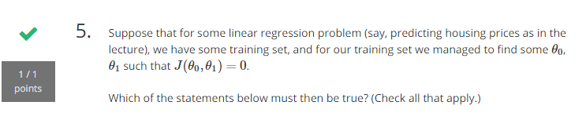

Min J = 0